Name

Mathematics Stage 5 Path
Coordinate Geometry Formulas

Book 1 | Apply the midpoint, gradient, and distance formulas | Version: 260314  Feedback:  https://MrDingMaths.com
Contents
Syllabus Content 2
Midpoint Formula 3
Gradient Formula 8
Distance Formula 11

Syllabus Content
MA5-LIN-P-01 describes and applies transformations, the midpoint, gradient/slope and distance formulas, and equations of lines to solve problems
Apply formulas to find the midpoint and gradient/slope of an interval on the Cartesian plane
- Apply the formula to find the midpoint of the interval joining 2 points on the Cartesian plane:
$$M\left(x,y\right)=\left(\frac{x_{1}+x_{2}}{2},\frac{y_{1}+y_{2}}{2}\right)$$
- Use the relationship $m=\frac{rise}{run}$ to establish the formula for the gradient/slope ($m)$ of the interval joining the 2 points $\left(x_{1}, y_{1}\right)$ and $\left(x_{2},y_{2}\right)$ on the Cartesian plane: $m=\frac{y_{2} - y_{1}}{x_{2} -{ x}_{1}}$
- Apply the gradient formula to find the gradient of the interval joining 2 points on the Cartesian plane
Apply the distance formula to find the distance between 2 points located on the Cartesian plane
- Apply knowledge of Pythagoras’ theorem to establish the formula for the distance ($d)$ between the 2 points $\left(x_{1}, y_{1}\right)$ and $\left(x_{2},y_{2}\right)$ on the Cartesian plane: $d=\sqrt{{\left(x_{2}-x_{1}\right)}^{2}+{\left(y_{2}-y_{1}\right)}^{2}}$
- Apply the distance formula to find the distance between 2 points on the Cartesian plane

Midpoint Formula

- Midpoint Formula
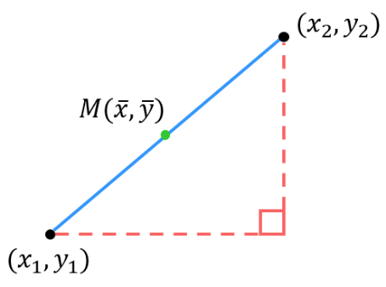
For two coordinates $(x_{1},y_{1})$ and $(x_{2},y_{2})$:

$$M=\left(mean of x, Mean of y\right) \\ M=\left(\frac{x_{1}+x_{2}}{2},\frac{y_{1}+y_{2}}{2}\right)$$

- Example Calculate midpoint using the formula
Calculate the midpoint of the interval between these points.
$(-4, 3)$ and $\left(8 , -2\right)$  $x_{1} y_{1} x_{2} y_{2}$  $M=(2, 0.5)$ | $\left(-3,-5\right)$ and $(2 , 8)$  $x_{1} y_{1} x_{2} y_{2}$  $M=(-0.5, 1.5)$
  $$\overline{x}=\frac{x_{1}+x_{2}}{2} \\ =\frac{-4+8}{2}=2$$ | $$\overline{y}=\frac{y_{1}+y_{2}}{2} \\ =\frac{3+(-2)}{2}=0.5$$
  $$\overline{x}=\frac{x_{1}+x_{2}}{2} \\ =\frac{-3+2}{2}=-0.5$$ | $$\overline{y}=\frac{y_{1}+y_{2}}{2} \\ =\frac{-5+8}{2}=1.5$$

- Guided Practice
Calculate the midpoint of the interval between these points.
- $(2,3)$ and $(6,9)$  $x_{1} y_{1} x_{2} y_{2}$  $M=\left( , \right)$  $$(4, 6)$$ | - $(-2,6)$ and $(8,-1)$  $M=\left( , \right)$  $$(3, 2.5)$$
  $$\overline{x}=\frac{x_{1}+x_{2}}{2}$$ | $$\overline{y}=\frac{y_{1}+y_{2}}{2}$$
  $$\overline{x}=\frac{x_{1}+x_{2}}{2}$$ | $$\overline{y}=\frac{y_{1}+y_{2}}{2}$$
- $\left(-5.5, 4.5\right)$and $(7, -1)$  $$(0.75, 1.75)$$ | - $(-5,-6)$ and $(2,4)$  $$\left(-1.5,-1\right)$$

- Key Ideas
- The midpoint is the …………… of the $x$ and $y$ coordinates.

Foundation
- Find the midpoint of the $x$ coordinates and the find the midpoint of the $y$ coordinates.
- $\left(2,7\right)$ and $\left(14,15\right)$  $$(8, 11)$$ | - $\left(5,2\right)$ and $\left(23,14\right)$  $$(14, 8)$$ | - $\left(1,14\right)$ and $\left(19,22\right)$  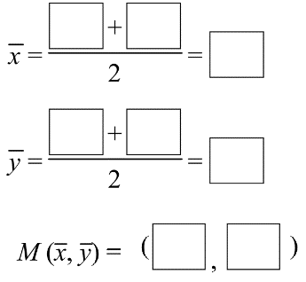  $$(10, 18)$$
- $(14,2)$ and $\left(8,6\right)$  $\overline{x}=$ …………………  $\overline{y}=$ …………………  $M=$ ( , )  $$(11, 4)$$ | - $\left(9,17\right)$ and $\left(3,8\right)$  $\overline{x}=$ …………………  $\overline{y}=$ …………………  $M=$ ( , )  $$(6, 12.5)$$ | - $\left(6,0\right)$ and $\left(11,13\right)$  $\overline{x}=$ …………………  $\overline{y}=$ …………………  $M=$ ( , )  $$(8.5, 6.5)$$
- $(-4,-3)$ and $\left(8,-11\right)$  $$(2, -7)$$ | - $\left(2,-3\right)$ and $\left(-6,9\right)$  $$(-2, 3)$$ | - $\left(-1,-6\right)$ and $\left(-3,10\right)$  $$(-2, 2)$$
- $(7,-5)$ and $\left(-3,9\right)$  $$(2, 2)$$ | - $\left(-9,-2\right)$ and $\left(-1,-9\right)$  $$(-5, -5.5)$$ | - $\left(0,-5\right)$ and $\left(-10,4\right)$  $$(-5, -0.5)$$

Development
- Calculate the midpoint of these coordinates.
- $(0,0)$ and $(4,2)$  (2, 1) | - $(4,8)$ and $(-1,1)$  (1.5, 4.5)
- $(0,0)$ and $(2,4)$  (1, 2) | - $\left(4,8\right)$ and $\left(-1,-1\right)$  (1.5, 3.5)
- $(0,0)$ and $(4,8)$  (2, 4) | - $(-4,8)$ and $(-1,-1)$  (-2.5, 3.5)
- $(4,8)$ and $(0,0)$  (2, 4) | - $(4,8)$ and $(-2,-2)$  (1, 3)
- $(4,8)$ and $(2,2)$  (3, 5) | - $(-4,8)$ and $(-2,-2)$  (-3, 3)
- $(4,8)$ and $(4,4)$  (4, 6) | - $(-4,-8)$ and $(-2,-2)$  (-3, -5)
- $(4,8)$ and $(3,3)$  (3.5, 5.5) | - $(-2,-4)$ and $(-2,-2)$  (-2, -3)
- $(4,8)$ and $(9,9)$  (6.5, 8.5) | - $(-20,-40)$ and $(-20,-20)$  (-20, -30)
- $(4,8)$ and $(10,10)$  (7, 9) | - $(-200,-400)$ and $(-200,-200)$  (-200, -300)
- $(4,8)$ and $(1,1)$  (2.5, 4.5) | - $(-200,-200)$ and $(200,200)$  (0, 0)

- Calculate the midpoint of these coordinates.
- $(-2, -2)$ and $(6, -3)$  (2, -2.5) | - $(0, 6)$ and $(6,0)$  (3, 3)
- $(2.5, 3)$ and $(4, -7)$  (3.25, -2) | - $(0.5, 0)$ and $(5,3)$  (2.75, 1.5)
- $(51, -12)$ and $(-36, 11)$  (7.5, -0.5) | - $(2a,4b)$ and $(4a,6b)$  (3a, 5b)
- $(5p, 3q)$ and $(-3p, 5q)$  (p, 4q) | - $\left(-4r,7s\right)$ and $\left(4r,-7s\right)$  (0, 0)

- Find the missing coordinates if $M$ is the midpoint of $A$ and $B$
$$A$$ | $$B$$ | $$M$$
$$(4,2)$$ | (8, 0) | $$(6,1)$$
$$(7,1)$$ | (-3, 1) | $$(2,1)$$
(1, -4) | $$(3,6)$$ | $$(2,1)$$
(-6, 5) | $$(0,-1)$$ | $$(-3,2)$$
(-6, 9) | $$(4,4)$$ | $$(-1,6.5)$$

- 2018 HSC Advanced Band 2
The point $(9, 5)$ is the midpoint of the interval PQ, where $P$ has coordinates $(5,3)$.
What are the coordinates of $Q$?

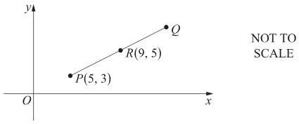

$$(13, 7)$$
- Find the values of $a$ and $b$ when:
- midpoint of $(a,3)$ and $(7,b)$ is $(5,4)$.  $$a = 3, b = 5$$ | - midpoint of $(a,-1)$and $(2,b)$ is $(-1,2).$  $$a = -4, b = 5$$
  $$\overline{x}=\frac{x_{1}+x_{2}}{2}$$  $$5=\frac{a+7}{2}$$ | $$\overline{y}=\frac{y_{1}+y_{2}}{2}$$
- midpoint of $(-3,a)$ and $(b,2)$ is $\left(-\frac{1}{2},0\right)$.  $$a = -2, b = 2$$ | - midpoint of $(-5,a)$and $(b,-4)$ is $\left(-\frac{3}{2},\frac{7}{2}\right).$  $$a = 11, b =2$$

Mastery
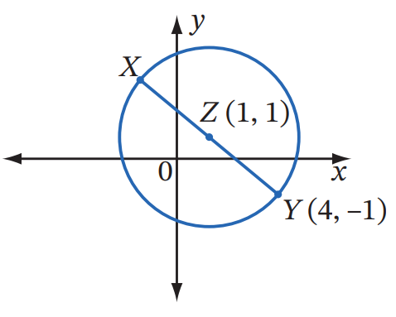
- The circle has diameter $XY$ and centre $Z$. What are the coordinates of $X$?

Midpoint of diameter gives centre:
$$\frac{x_{X}+ 4}{2}= 1 and\frac{y_{X}+ \left(-1\right)}{2}= 1$$
$$x_{X}+ 4 = 2$$
$$x_{X}= -2$$
$$y_{X}- 1 = 2$$
$$y_{X}= 3$$
$$X(-2, 3)$$

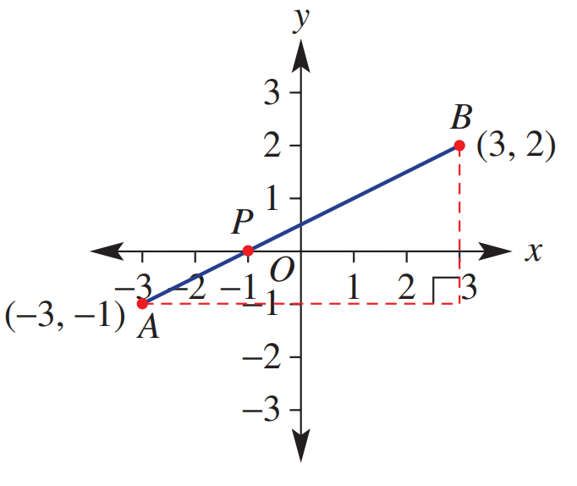
- From left to right, this line segment shows point $P(-1, 0)$ dividing the segment in the ratio 1 : 2.
  - What fraction of the horizontal distance
between the end points is P from A?

$$\frac{1}{3}$$
  - What fraction of the vertical distance
between the end points is P from A?

$$\frac{1}{3}$$
  - Hence find $P$ algebraically.
Coordinates of $P$ are one third the distance from A to B
$$x coordinate: -3+\frac{1}{3}\left(3--3\right)=-1$$
$$y coordinate: -1+\frac{1}{3}\left(2--1\right)=0$$
$$\left(-1,0\right)$$
- Find the coordinates of point $P$ that divides $A(-4, 9)$ and $B(1, -1)$ in the ratio 2 : 3.

Coordinates of P are two fifths the distance from A to B
$$x coordinate: -4 +\frac{2}{5}\left(1 - \left(-4\right)\right)= -2$$
$$y coordinate: 9 +\frac{2}{5}\left(-1 - 9\right)= = 5$$
$$P(-2, 5)$$
- Find the coordinates of point $P$ that divides $A(-2, -3)$ and $B(4, 0)$ in the ratio 3 : 2.

Coordinates of P are three fifths the distance from A to B
$$x coordinate: -2 +\frac{3}{5}\left(4 - \left(-2\right)\right)=\frac{8}{5}$$
$$y coordinate: -3 +\frac{3}{5}\left(0 - \left(-3\right)\right)= -\frac{6}{5}$$
$$P\left(\frac{8}{5}, -\frac{6}{5}\right)$$

Gradient Formula

- Gradient Formula
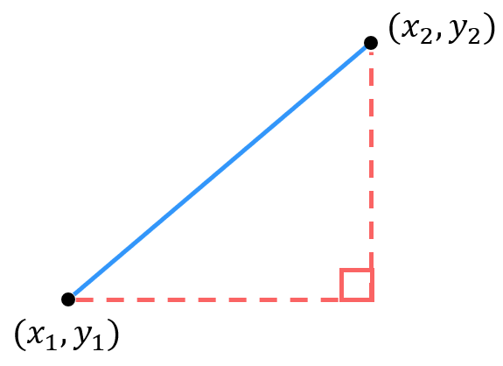
For two coordinates $(x_{1},y_{1})$ and $(x_{2},y_{2})$:
$$m=\frac{rise}{run} \\ m=\frac{y_{2}-y_{1}}{x_{2}-x_{1}}$$

- Example Calculate gradient using the formula
Calculate the gradient of the interval between these points.
$(4 , 2)$ and $\left(12 , 4\right)$  $x_{1} y_{1} x_{2} y_{2}$  $$m=\frac{y_{2}-y_{1}}{x_{2}-x_{1}} \\ =\frac{4-2}{12-4} \\ =\frac{2}{8}=\frac{1}{4}$$ | $(-3,8)$ and $\left(5,-2\right)$  $x_{1} y_{1} x_{2} y_{2}$  $$m=\frac{y_{2}-y_{1}}{x_{2}-x_{1}} \\ =\frac{-2-8}{5-(-3)} \\ =-\frac{10}{8}=-\frac{5}{4}$$

- Guided Practice
Calculate the gradient of the interval between these points.
- $(2,3)$ and $(5,8)$  $x_{1} y_{1} x_{2} y_{2}$  $$m=\frac{y_{2}-y_{1}}{x_{2}-x_{1}}$$  $=$  $=$  $$\frac{5}{3}$$ | - $(-2,5)$ and $(0,-6)$  $$m=\frac{y_{2}-y_{1}}{x_{2}-x_{1}}$$  $=$  $=$  $$-\frac{11}{2}$$
- $(-1,-2)$ and $(-3,-7)$  $$\frac{5}{2}$$ | - $(4,-3)$ and $(-4,1)$  $$-\frac{1}{2}$$

- Key Ideas
- The gradient is the change in …… divided by the change in ……

Foundation
- Find the gradient of each interval.
- $A(1, 4), B(5, 0)$  $$m=\frac{y_{2}-y_{1}}{x_{2}-x_{1}}$$  $=$  $=$  $$-1$$ | - $A(-2, -7), B(3, 3)$  $$2$$ | - $A(-5, -2), B(3, 2)$  $$\frac{1}{2}$$
- $A(3, 6), B(5, 5)$  $$-\frac{1}{2}$$ | - $A(-1, -2), B(1, 4)$  $$3$$ | - $A(-5, 7), B(15, -7)$  $$-\frac{7}{10}$$

- A line joins the two points (−1, 3) and (4, −2).
  - Calculate the gradient of the line, using $(x_{1}, y_{1})=(-1, 3)$ and $(x_{2},y_{2})=(4, -2).$

$$m =\frac{-2 - 3}{4 - \left(-1\right)}= -\frac{5}{5}= -1$$
  - Calculate the gradient of the line, using $(x_{1}, y_{1})=(4, -2)$ and $(x_{2},y_{2})=(-1, 3).$

$$m =\frac{3 - \left(-2\right)}{-1 - 4}=\frac{5}{-5}= -1$$
  - Do you get the same gradient even if you switch $(x_{1}, y_{1})$ and $(x_{2},y_{2})$?

Yes

Development
- Read the example carefully and answer the questions.
Akemi’s work:  Calculate the gradient.  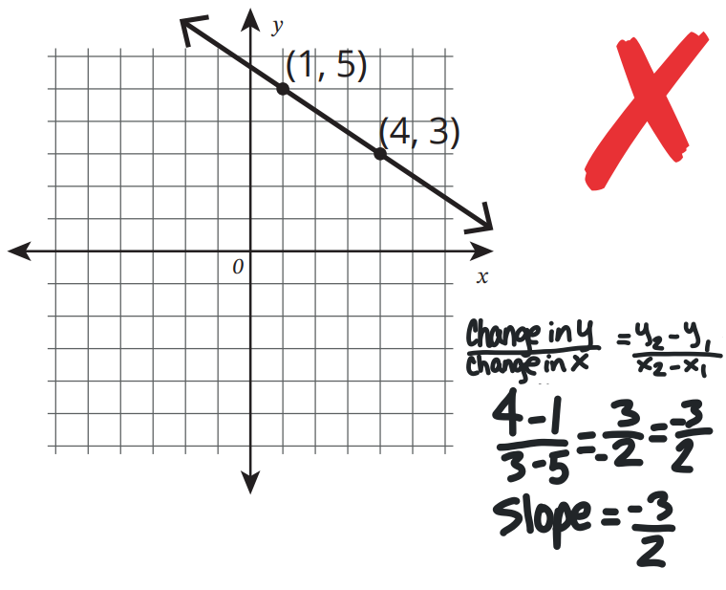 | What did Akemi do wrong when substituting the points into the slope formula?  She did change in $x$ over change in $y$  Using the graph, how could she have checked her work?  Use the gridlines to see if the slope goes 3 down for every 2 across.  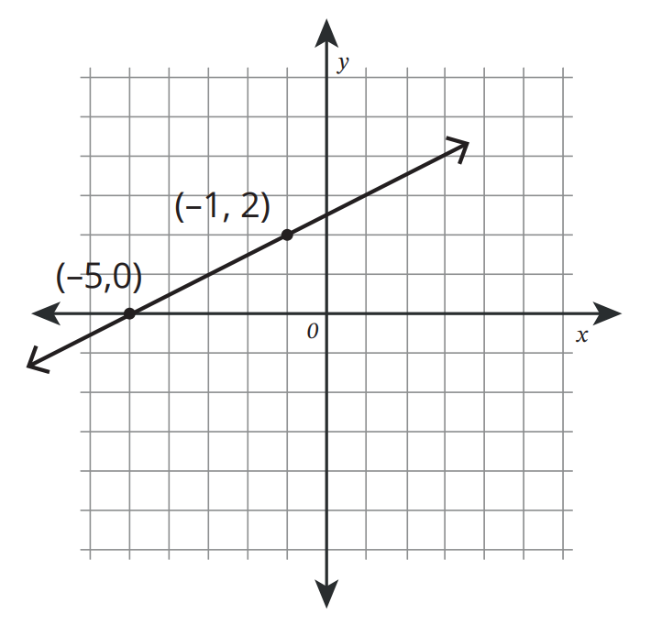  Calculate the gradient:  $$\frac{1}{2}$$

- Collinear points lie on the same line. Three points $A,B,C$ are collinear if $AB$ and $BC$ have the same gradient, because then $AB$ and $BC$ are parallel lines passing through a common point $B$.
  - Determine whether $A\left(-2,5\right)$, $B\left(1,3\right)$ and $C\left(7,-1\right)$ are collinear.
$m_{AB}=$ | $m_{BC}=$

collinear
  - $P\left(-2, 7\right), Q\left(1, 1\right), R\left(4, -6\right)$

not collinear
  - $P\left(-5, -4\right), Q\left(-2, -2\right), R\left(1, 0\right)$

collinear

Distance Formula

- Distance Formula
For two coordinates $(x_{1},y_{1})$ and $(x_{2},y_{2})$:

$$d=\sqrt{run^{2}+rise^{2}} \\ d=\sqrt{{\left(x_{2}-x_{1}\right)}^{2}+{\left(y_{2}-y_{1}\right)}^{2}}$$

- Example Calculate distance using the formula
Calculate the distance of the interval through these points. Answer as a surd and to 2 d.p.
$(2,6)$ and $\left(5,1\right)$  $x_{1} y_{1} x_{2} y_{2}$  $d=\sqrt{{\left(x_{2}-x_{1}\right)}^{2}+{\left(y_{2}-y_{1}\right)}^{2}}$  $=\sqrt{{\left(5-2\right)}^{2}+{\left(1-6\right)}^{2}}$  $=\sqrt{34}$  $≈5.83$ | $\left(-3,5\right)$ and $(6,-4)$  $x_{1} y_{1} x_{2} y_{2}$  $d=\sqrt{{\left(6-(-3)\right)}^{2}+{\left(-4-5\right)}^{2}}$  $=\sqrt{{\left(9\right)}^{2}+{\left(-9\right)}^{2}}$  $=\sqrt{162}$  $≈12.73$

- Guided Practice
Calculate the length of the interval between these points. Answer as a surd and to 2 d.p.
- $(-2,3)$ and $(5,4)$  $d=\sqrt{{\left(x_{2}-x_{1}\right)}^{2}+{\left(y_{2}-y_{1}\right)}^{2}}$  $=\sqrt{{\left( \right)}^{2}+{\left( \right)}^{2}}$  $=\sqrt{ }$  $5\sqrt{2}$ or 7.07 | - $(0,4)$ and $(3,6)$  $d=\sqrt{{\left(x_{2}-x_{1}\right)}^{2}+{\left(y_{2}-y_{1}\right)}^{2}}$  $=\sqrt{{\left( \right)}^{2}+{\left( \right)}^{2}}$  $=\sqrt{ }$  $\sqrt{13}$ or 3.61
- $(-3,4)$ and $(2,4)$  5 | - $(1,-2)$ and $(-4,3)$  $5\sqrt{2}$ or 7.07

- Key Ideas
- We calculate the distance between two points using …………………’s theorem.

Foundation
- Find the length, or distance, of each interval. Answer to 1 d.p. where necessary.
- $A(1, 4), B(5, 1)$  5 | - $A(-2, 7), B(3, -5)$  13 | - $A(-5, -2), B(3, 4)$  10
- $A(3, 6), B(5, 4)$  2.8 | - $A(-4, -1), B(4, 3)$  8.9 | - $A(5, -12), B(0, 0)$  13

- Find the length between these intervals without drawing it. Answer in exact form.
- $(0,0)$ and $(6,8)$  10 | - $(1,1)$ and $(8,-10)$  $$\sqrt{170}$$
- $\left(0,0\right)$ and $\left(-6,8\right)$  10 | - $(1,1)$ and $(-1,-1)$  $$\sqrt{8}$$
- $(0,0)$ and $(-6,-8)$  10 | - $(15, 1)$ and $(8, 12)$  $$\sqrt{170}$$
- $(0,0)$ and $(-6,-8)$  10 | - $(15, 23)$ and $(8, 12)$  $$\sqrt{170}$$
- $(1,1)$ and $(7,9)$  $$10$$ | - $(1,1)$ and $(-16,20)$  $$\sqrt{650}$$
- $(1,1)$ and $(8,10)$  $$\sqrt{130}$$ | - $(1,1)$ and $(-17,19)$  $$\sqrt{648}$$
- $(1,1)$ and $(-8,10)$  $$\sqrt{162}$$ | - $(-8,10)$ and $(-17,19)$  $$\sqrt{162}$$

Development
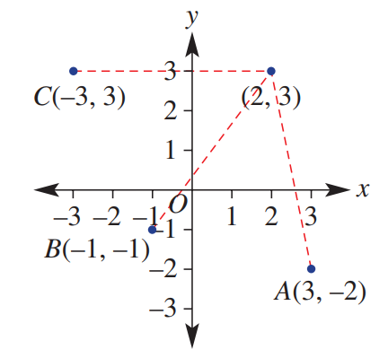
- Which of the points $A,B,$or $C$ are closest to the point $(2,3)$?

B and C are both 5 units away from (2, 3)

- Calculate the length, gradient, and midpoint of each line segment AB.
Give your answers to 1 decimal place where necessary.
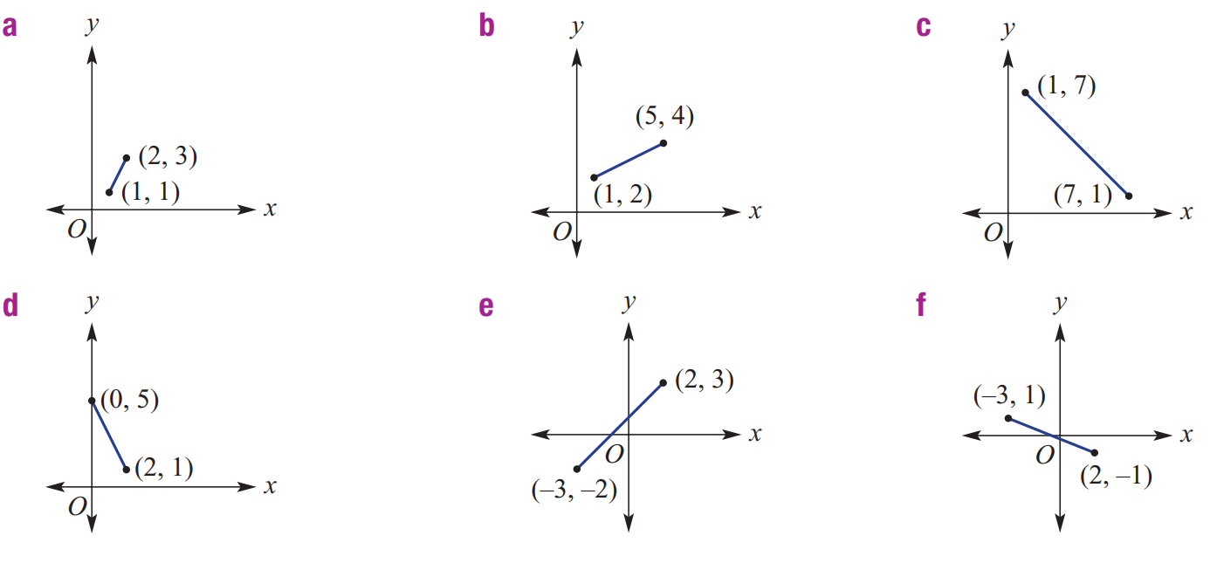  $$Length: \sqrt{{\left(2-1\right)}^{2}+ {\left(3-1\right)}^{2}}= 2.2$$  $$Gradient:\frac{3-1}{2-1}= 2$$  $$Midpoint: \left(\frac{1+2}{2},\frac{1+3}{2}\right)= \left(1.5, 2\right)$$ | $$Length: \sqrt{{\left(5-1\right)}^{2}+ {\left(4-2\right)}^{2}}= 4.5$$  $$Gradient:\frac{4-2}{5-1}= 0.5$$  $$Midpoint: \left(\frac{1+5}{2},\frac{2+4}{2}\right)= \left(3, 3\right)$$ | $$Length: \sqrt{{\left(7-1\right)}^{2}+ {\left(1-7\right)}^{2}}= 8.5$$  $$Gradient:\frac{1-7}{7-1}= -1$$  $$Midpoint: \left(\frac{1+7}{2},\frac{7+1}{2}\right)= \left(4, 4\right)$$
$$Length: \sqrt{{\left(2-0\right)}^{2}+ {\left(1-5\right)}^{2}}= 4.5$$  $$Gradient:\frac{1-5}{2-0}= -2.0$$  $$Midpoint: \left(\frac{0+2}{2},\frac{5+1}{2}\right)= \left(1.0, 3.0\right)$$ | $$Length: \sqrt{{\left(2-\left(-3\right)\right)}^{2}+ {\left(3-\left(-2\right)\right)}^{2}}= 7.1$$  $$Gradient:\frac{3-\left(-2\right)}{2-\left(-3\right)}= 1$$  $$Midpoint: \left(\frac{-3+2}{2},\frac{-2+3}{2}\right)= \left(-0.5, 0.5\right)$$ | $$Length: \sqrt{{\left(2-\left(-3\right)\right)}^{2}+ {\left(-1-1\right)}^{2}}= 5.4$$  $$Gradient:\frac{-1-1}{2-\left(-3\right)}= -0.4$$  $$Midpoint: \left(\frac{-3+2}{2},\frac{1+\left(-1\right)}{2}\right)= \left(-0.5, 0\right)$$

Mastery
- Find the value of $a$ when the distance between:
- $(1,a)$ and $(3,5)$ is $\sqrt{8}$  $$\sqrt{{\left(3-1\right)}^{2}+{\left(5-a\right)}^{2}}= \sqrt{8}$$  $$4+(5-a)² = 8$$  $$(5-a)² = 4$$  $$5-a = ±2$$  $$a = 3 or 7$$ | - $(a, -1)$ and $(4,-3)$ is $\sqrt{29}$  $$\sqrt{{\left(4-a\right)}^{2}+{\left(-3-\left(-1\right)\right)}^{2}}= \sqrt{29}$$  $$(4-a)²+4 = 29$$  $$(4-a)² = 25$$  $$4-a = ±5$$  $$a = -1 or 9$$

- NAPLAN A
Calculate the values of $p$ if the distance between $(p,3)$ and $\left(1,p\right)$ are exactly 10 units apart.
$$\sqrt{{\left(1-p\right)}^{2}+{\left(p-3\right)}^{2}}= 10$$
$${\left(1-p\right)}^{2}+{\left(p-3\right)}^{2}= 100$$
$$1-2p+p²+p²-6p+9 = 100$$
$$2p²-8p-90 = 0$$
$$p²-4p-45 = 0$$
$$(p-9)(p+5) = 0$$
$$p = 9 or -5$$

- Points $A$, $B$ and $C$ lie on a straight line.
Point $A$ has coordinates $(-4, 1)$
Point $B$ has coordinates $(7, -5)$
Point $C$ is such that $AB :BC = 4 :7$.
Work out the length of line segment AC. Give your answer to 1 decimal place.

$$AB^{2}= {\left(7 - \left(-4\right)\right)}^{2}+ {\left(-5 - 1\right)}^{2}= 157$$
$$AB = \sqrt{157}$$
$$BC =\frac{7}{4}AB$$
$$=\frac{7}{4}\sqrt{157}$$

$$AC = AB + BC$$
$$= AB +\frac{7}{4}AB$$
$$=\frac{11}{4}AB$$
$$=\frac{11}{4}\sqrt{157}$$
$$= 34.4$$

